

**CSE 280 ADVANCE JAVA**

**STUDENT WORK BOOK**

|  |  |  |
| --- | --- | --- |
| **Name** | **:** | M.Sathishkumar |
| **Unique ID** | **:** | E0119052 |
| **Year** | **:** | II |
| **Quarter** | **:** | Q6 |
| **Department** | **:** | B.Tech CSE (AI &ML) |
| **Faculty Name** | **:** | Prof. Ashok Kumar |
| **Academic Year** | **:** | 2020-2021 |

**Date: 19-11-2020**

**Question 1:**

Write a program to solve quadratic equation

**Program:**

import java.io.*;

import javax.servlet.*;

import javax.servlet.http.*;

import java.sql.*;

public class Day4 extends HttpServlet {

public void init() throws ServletException {

}

public void doGet(HttpServletRequest request, HttpServletResponse response)

throws ServletException, IOException {

double secondRoot = 0, firstRoot = 0;

int a=Integer.parseInt(request.getParameter("p1"));

int b=Integer.parseInt(request.getParameter("p2"));

int c=Integer.parseInt(request.getParameter("p3"));

double determinant = (b*b)-(4*a*c);

double sqrt = Math.sqrt(determinant);

response.setContentType("text/html");

PrintWriter out = response.getWriter();

if(determinant>0){

firstRoot = (-b + sqrt)/(2*a);

secondRoot = (-b - sqrt)/(2*a);

out.println("Roots are :: "+ firstRoot +" and "+secondRoot);

}else if(determinant == 0){

out.println("Root is :: "+(-b + sqrt)/(2*a));

}}

public void destroy() { } }

**Output:**

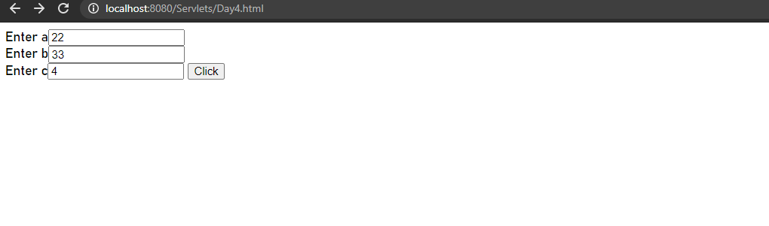

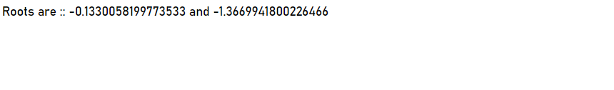

**Date: 19-11-2020**

**Question 2:**

Find the LCM of two numbers

**Program:**

import java.io.*;

import javax.servlet.*;

import javax.servlet.http.*;

import java.sql.*;

public class D2 extends HttpServlet {

public void init() throws ServletException {

}

public void doGet(HttpServletRequest request, HttpServletResponse response)

throws ServletException, IOException {

int a=Integer.parseInt(request.getParameter("p1"));

int b=Integer.parseInt(request.getParameter("p2"));

int lcm;

response.setContentType("text/html");

PrintWriter out = response.getWriter();

lcm = (a > b) ? a : b;

// Always true

while(true) {

if( lcm % a == 0 && lcm % b == 0 ) {

out.println("<html><body>The LCM of " +a+ "and "+b + "is" +lcm+ "<br></body></html>");

break;

}

++lcm;

}

}

public void destroy() {

}

}

**Output:**

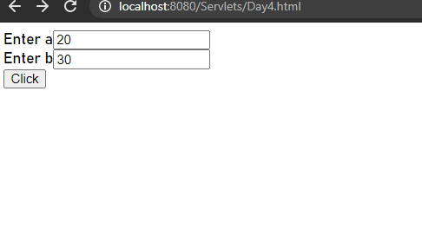

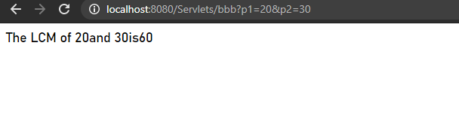

**Date: 19-11-2020**

**Question 3:**

Find the HCF of two numbers

**Program:**

import java.io.*;

import javax.servlet.*;

import javax.servlet.http.*;

import java.sql.*;

public class D3 extends HttpServlet {

public void init() throws ServletException {

}

public void doGet(HttpServletRequest request, HttpServletResponse response)

throws ServletException, IOException {

int n1=Integer.parseInt(request.getParameter("p1"));

int n2=Integer.parseInt(request.getParameter("p2"));

response.setContentType("text/html");

PrintWriter out = response.getWriter();

int gcd=1;

for(int i = 1; i <= n1 && i <= n2; ++i)

{

// Checks if i is factor of both integers

if(n1 % i==0 && n2 % i==0)

gcd = i;

}

out.println("<html><body>The HCF of " +n1+ "and "+n2 + "is" +gcd+ "<br></body></html>");

}

public void destroy() {

}

}

**Output:**

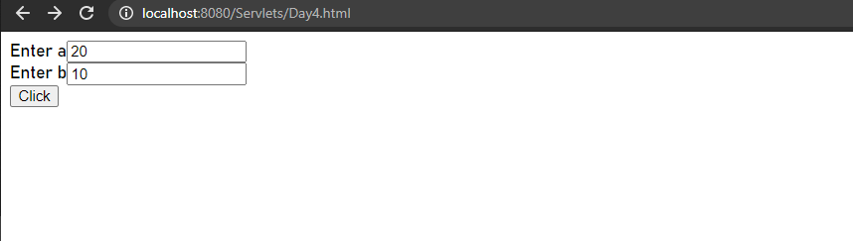

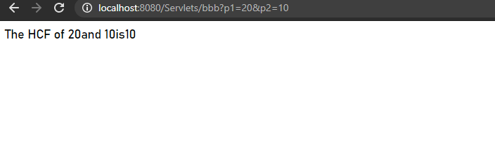

**Date: 19-11-2020**

**Question 4:**

Find the sum of natural numbers in a given interval

**Program:**

import java.io.*;

import javax.servlet.*;

import javax.servlet.http.*;

import java.sql.*;

public class D4 extends HttpServlet {

public void init() throws ServletException {

}

public void doGet(HttpServletRequest request, HttpServletResponse response)

throws ServletException, IOException {

int a=Integer.parseInt(request.getParameter("p1"));

response.setContentType("text/html");

PrintWriter out = response.getWriter();

int sum=0;

for(int i = 1; i <= a; ++i)

{

sum += i;

}

out.println("<html><body>sum is " +sum+ "</body></html>");

}

public void destroy() {

}

}

**Output:**

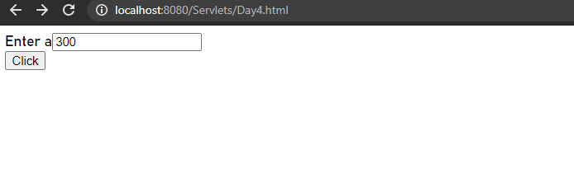



**Date: 19-11-2020**

**Question 5:**

import java.io.*;

import javax.servlet.*;

import javax.servlet.http.*;

import java.sql.*;

public class D6 extends HttpServlet {

public void init() throws ServletException {

}

public void doGet(HttpServletRequest request, HttpServletResponse response)

throws ServletException, IOException {

int a=Integer.parseInt(request.getParameter("p1"));

int expo=Integer.parseInt(request.getParameter("p2"));

long result = 1;

response.setContentType("text/html");

PrintWriter out = response.getWriter();

for(int i = 1; i <= expo; ++i)

{

result *= a;

out.println( +result+ "<br></body></html>");

}

}

public void destroy() {

}

}

**Output:**

